**What Is a Stack ?** **2**

**LIFO Principle :** **3**

**What Is Meant By Abstraction Data Structure ?** **4**

**Stack Using Array** **5**

1.Stack Class Structure And Code : 5

2.Push Operation : 6

2.1 Code : 6

2.2 Time Complexity = 1 6

3.Pop Operation : 7

3.1 Code : 7

3.2 Time Complexity = 1 7

4.Peek Operation : 8

4.1 Code : 8

4.2 Time Complexity = 1 8

5.Example : 9

**Stack Using LinkedList** **10**

1.Stack Class Structure And Code : 10

2.Push Operation : 11

2.1 Code : 11

2.2 Time Complexity = 1 11

3.Pop Operation : 12

3.1 Code : 12

3.2 Time Complexity = 1 12

4.Peek Operation : 13

4.1 Code : 13

4.2 Time Complexity = 1 13

5.Example : 14

# **What Is a Stack ?**

A Stack Is an Abstraction Data Structures Based On LIFO Principle ( Last in First Out ).

You can think of the stack data structure as Stack of plates.

you can only take a plate from the top of the stack, and you can only add a plate to the top of the stack.



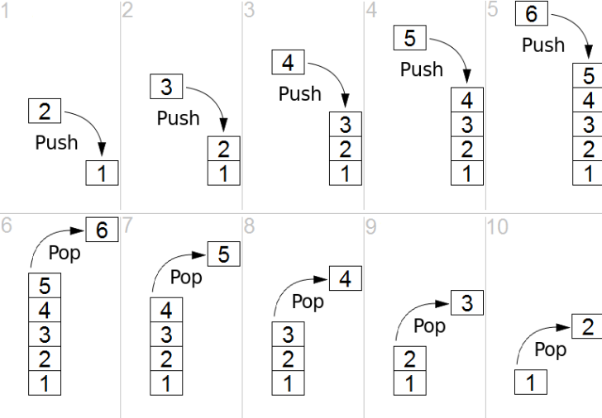

# LIFO Principle :

**Stack allows all operations to occur at Only One Side.**

LIFO Mean :

Last Element Inserted Must Be The First Element To Remove.

Stack Operations:

1. Push : Insert Element At The Top Of Stack.
2. Pop : Delete Element At The Top Of Stack.
3. Peek : Return Element At The Top Of Stack Without Deleting.

# **What Is Meant By Abstraction Data Structure ?**

In General Abstraction Term Mean Define What ,, But Not Defined How .

Abstraction Data Structure is The Data Structure Which Described By Its Behavior Or Operations And Can Be Implemented By Different Data Structures.

Example : Stack Can Be Implemented By Array Or LinkedList.

But in Both Cases We Must Apply The LIFO Principle.

So What ?

→ Build Stack Based On LIFO Principle.

How ?

→ Stack Can Implemented By Array Or Linked List.

# **Stack Using Array**

## 1.Stack Class Structure And Code :

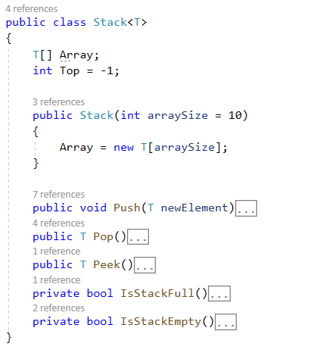

## 2.Push Operation :

### 2.1 Code :

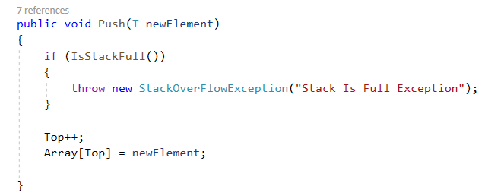

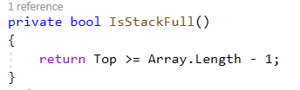

### 2.2 Time Complexity = 1

## 3.Pop Operation :

### 3.1 Code :

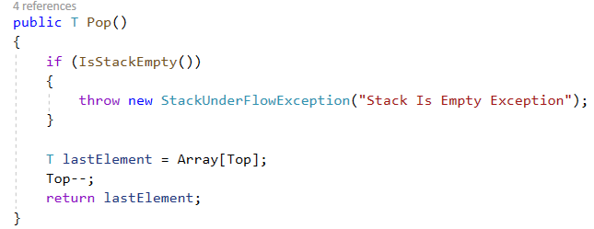

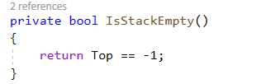

### 3.2 Time Complexity = 1

## 4.Peek Operation :

### 4.1 Code :

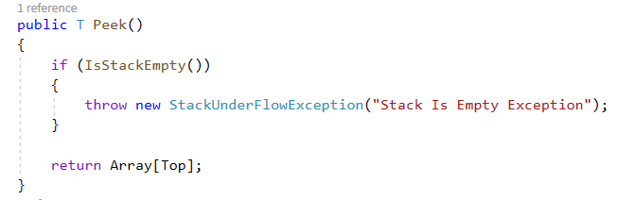

### 4.2 Time Complexity = 1

## 5.Example :

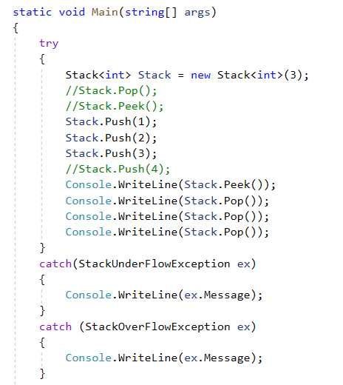

# **Stack Using LinkedList**

## 1.Stack Class Structure And Code :

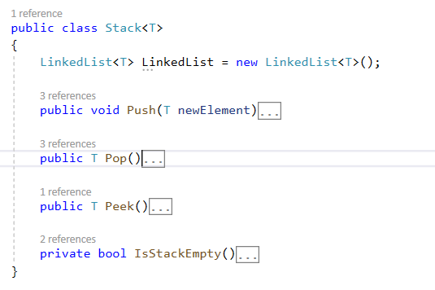

## 2.Push Operation :

### 2.1 Code :

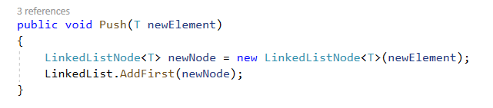

### 2.2 Time Complexity = 1

## 

## 

## 3.Pop Operation :

### 3.1 Code :

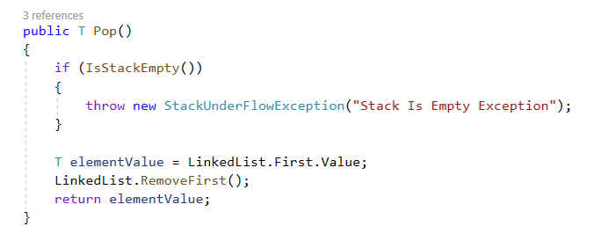

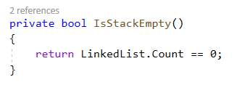

### 3.2 Time Complexity = 1

## 4.Peek Operation :

### 4.1 Code :

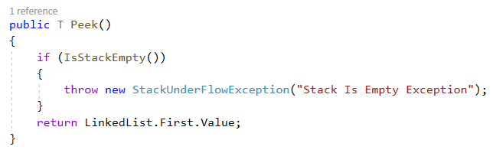

### 4.2 Time Complexity = 1

## 5.Example :

